**Class Diagrams**

For each game object we will be using classes to incorporate them into the scene, below demonstrates the relationships between each class:

**Player, Weapons and Enemies:**

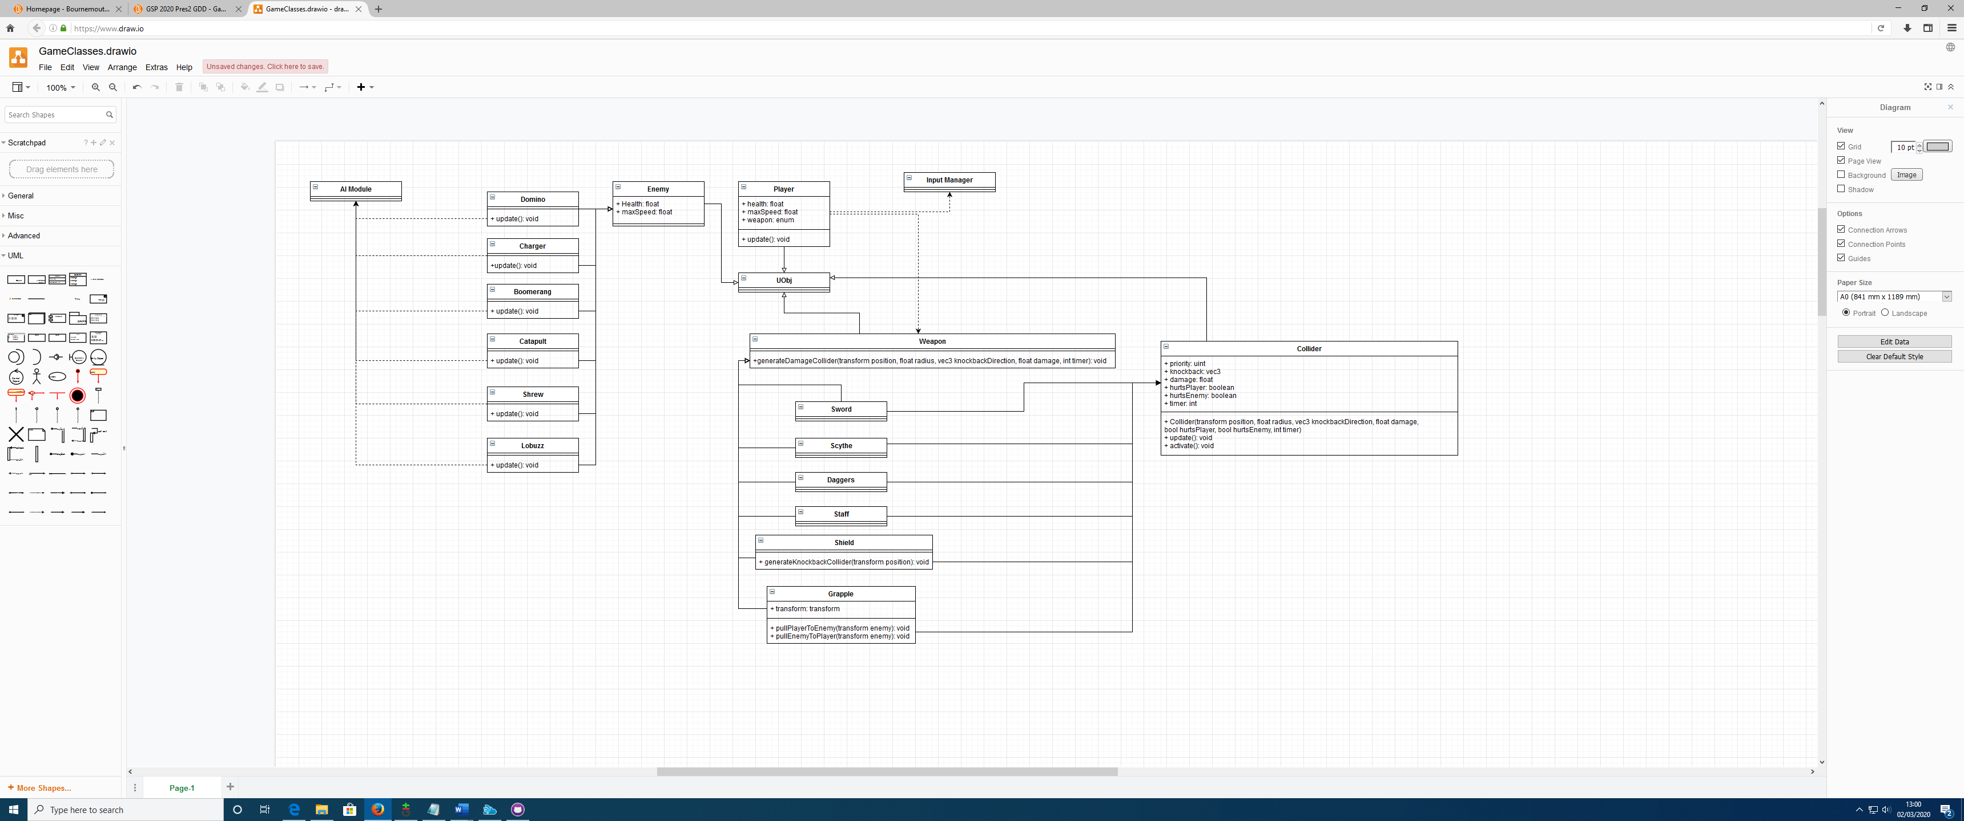

Figure - Class Diagram for player, weapons and enemies.

**Stage Traps:**

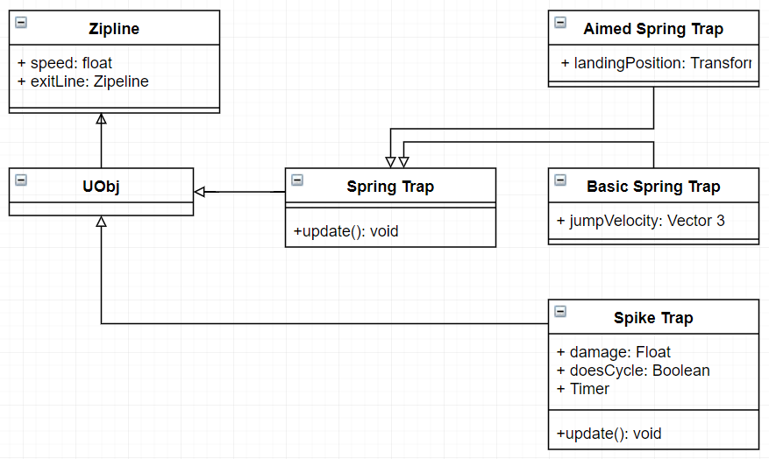

Figure 2 - Class Diagram for the spike trap, bounce pads and ziplines.